**DAILY ONLINE ACTIVITIES SUMMARY**

|  |  |  |  |  |  |  |  |
| --- | --- | --- | --- | --- | --- | --- | --- |
| **Date:** | **13 June 2020** | | | | **Name:** | **K ISHA HEGDE** | |
| **Sem & Sec** | **4th sem, 2nd year** | | | | **USN:** | **4al18cs031** | |
| **Online Test Summary** | | | | | | | |
| **Subject** | | **DATA COMMUNICATION (18cs46)** | | | | | |
| **Max. Marks** | | **30** | | **Score** | | **27** | |
| **Certification Course Summary** | | | | | | | |
| **Course** | **PYTHON** | | | | | | |
| **Certificate Provider** | | | **GUVI** | **Duration** | | | **6 hours** |
| **Coding Challenges** | | | | | | | |
| **Problem Statement:1 program** | | | | | | | |
| **Status: Executed** | | | | | | | |
| **Uploaded the report in Github** | | | | **Yes** | | | |
| **If yes Repository name** | | | | **[https://github.com/iishaii/locked-down_coding](https://github.com/iishaii/locked-down_coding" \o "https://github.com/iishaii/locked-down_coding)** | | | |
| **Uploaded the report in slack** | | | | **Yes** | | | |

**Online Test Summary**

**DATA COMMUNICATION (18cs46) was conducted of 30marks with duration of 30 minutes.**

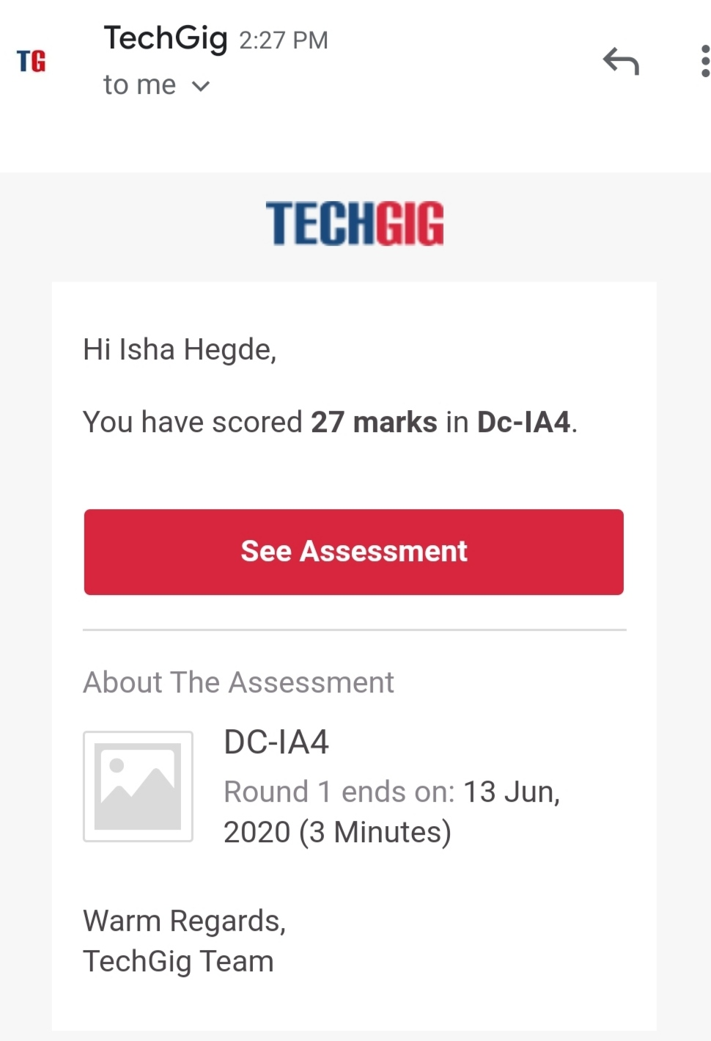

**Certification Course Summary:** **Today I completed the EXPERT MODULE, which is the last and final module in the PYTHON course.I attempted the final quiz and also received a certificate.**

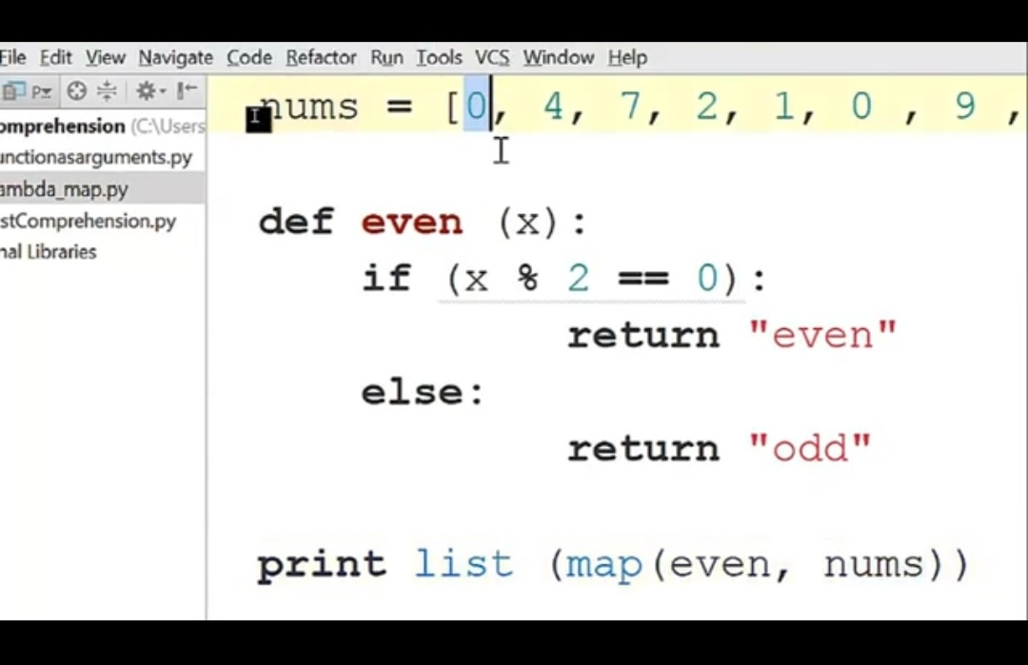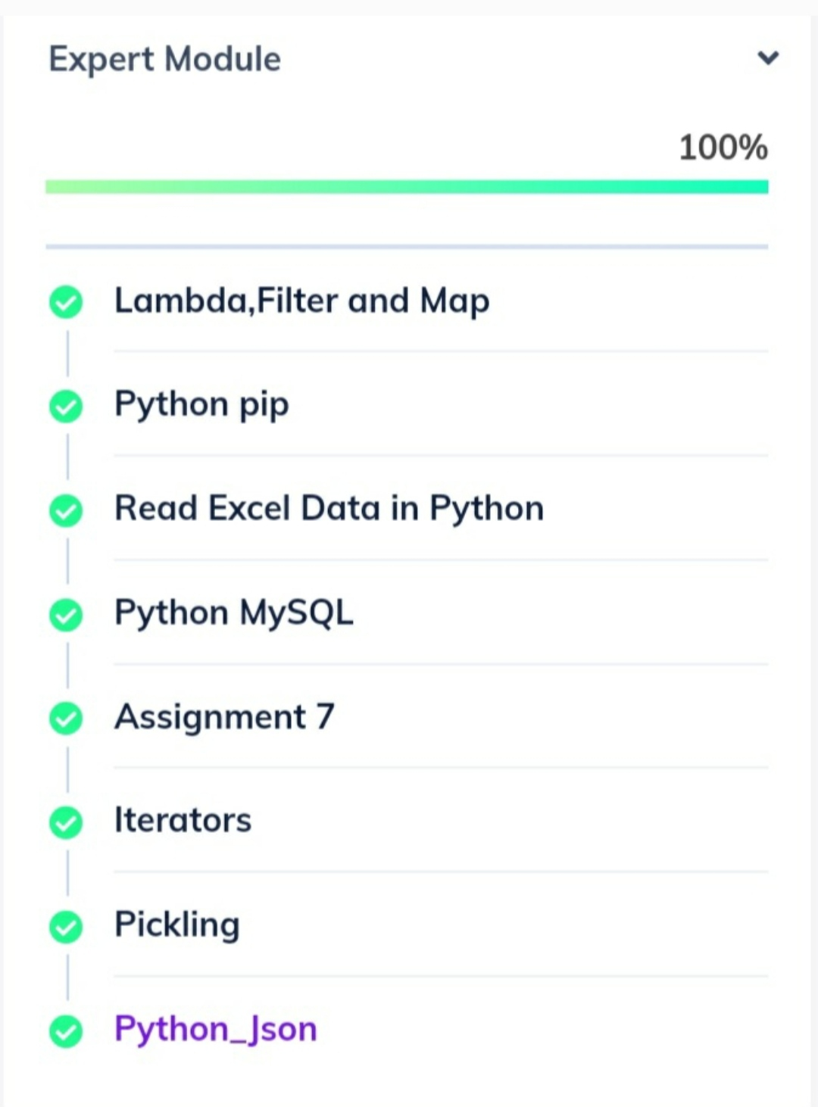



WEBINAR:

I had attended the webinar on E-COMMERCE conducted by IIDE on 8th jun and received the certificate for active participation.

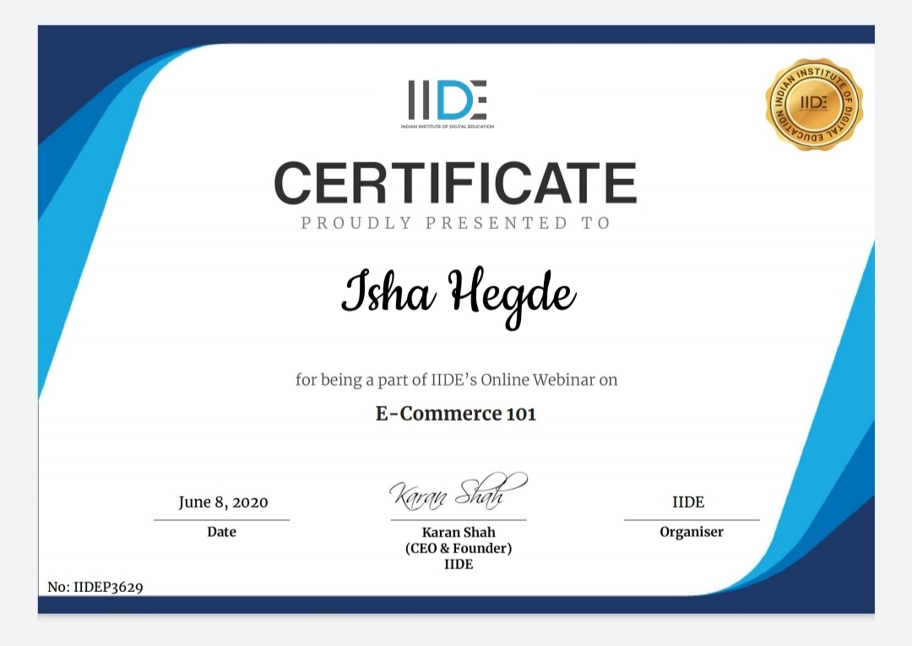

**Coding Challenges:**

Today I solved coding challenge,

**1.** **How to find the first non-repeated character of a given String?**

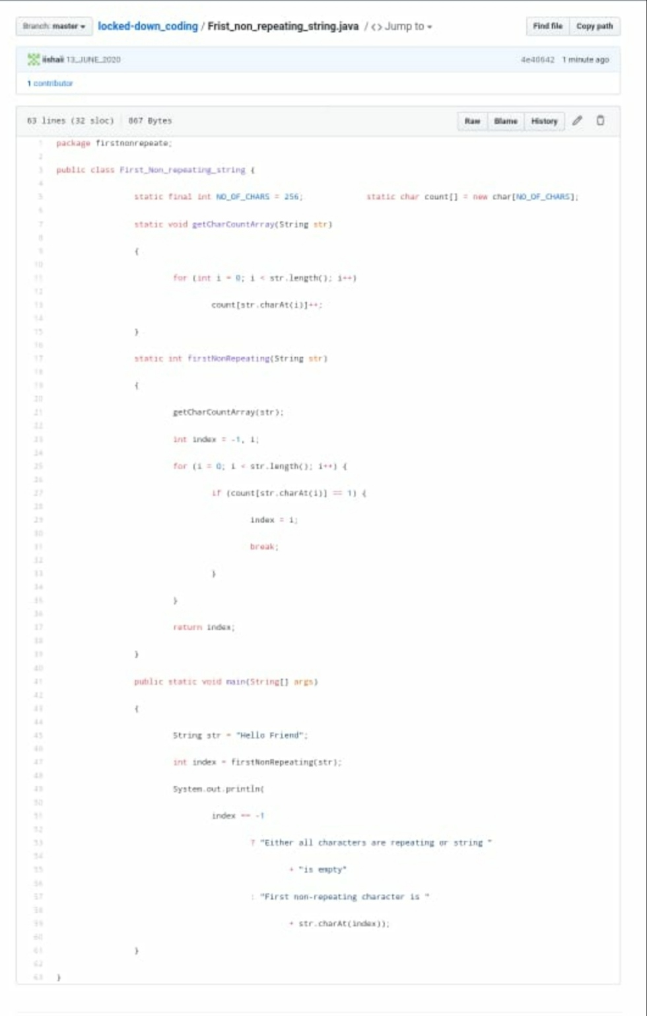

**I have uploaded the solution in GitHub**

**[https://github.com/iishaii/locked-down_coding](https://github.com/iishaii/locked-down_coding" \o "https://github.com/iishaii/locked-down_coding)**

